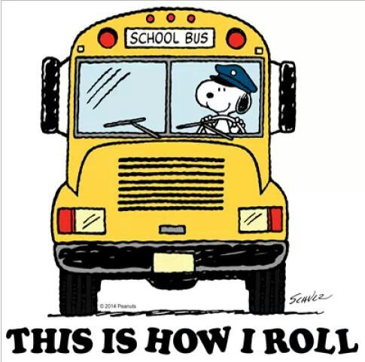

As stated above there is a spot on the back of the homework to fill out what your student will be having for lunch. We order hot lunch a day ahead of time. So please make sure to circle if your student will be ordering hot lunch for the following day. Money can be sent in on the day they are buying or you can send money or a check in to place on their debit card which is located in the lunch room. Students will have an AM and PM snack. It is preferred for snacks to packed separate from lunches and should be a healthy smaller portion food item. Don’t forget to send in snacks on days your student is getting hot lunch.

For the first few weeks we will be working hard in the classroom to learn our classroom rules. These rules help to create a positive learning environment for everyone. To enforce these class rules, our class has a green chip behavior. Our Classroom students earn a green chip for completing classroom tasks while following our classroom rules. If a student has trouble following one of the classroom rules during a task, they do not earn that green chip, and try again for the next task. Once a student has earned four green chips, they can select a reward from the reward choice board. Rewards include stickers, 5 min ipad time, drawing, candy, and more. A sheet will be coming home every day to communicate your student’s daily behavior. On one side the students circle info about the day, and the amount of rewards they earned for the day. Four rewards would be above and beyond. Three rewards would be most tasks performed while following the rules. The back side is filled out with the student and a teacher or parapro. The student gets a stamp for every class rule followed, if a student had trouble with one of the classroom rules, I will write a note indicating what happened during the day. Any questions feel free to let me know. We are always looking for donations for our treasure chest and candy. Thanks!

# Lunch/snack

# Paper coming Home

Your student has been bringing home a homework sheet every night and will so from now on. This is a worksheet that is titled “Last Night At Home.’” Please help your child to fill this out each night and return it to school the next morning. This sheet is to help facilitate conversation the next morning. This helps the students work on social skills and exercise their memories. On the back of the sheet is a spot for notes that you can use to send me messages, there is also a spot to indicate what your child is having for lunch. This sheet needs to be returned the next morning. The other worksheet that will be coming home with your child every day is a sheet that they will fill out at the end of everyday going over things we discussed during the day and on the back is a description of their behavior. This can stay at home.

Each month 1-2 students will be selected for that month’s student of the month. A worksheet will go home asking this selected student a few questions like their favorite sport, things they like to do, and their family. Please help them fill this out and return it along with a picture of their family. This will all be displayed on the student of the month board in our class for that month.

# Student of the Month

September

Mrs. Hemler’s Classroom Newsletter

### Miami Elementary

CLP

9/03/2019

Volume 10, Issue 1

# Classroom Behavior Plan

banner with apples and crayons

I told some of you at open house about scholastic book orders. Every month order forms will come home. If you would like to order books for your student you can do so online or sending in a check. This year I reached out to friends and family to donate a sponsorship that will send a book home each month with your student. Each month the book I choose will be written in the newsletter so you know which one is coming home and don’t order the same one.

**Scholastic Books**

## Reminders to Students

* Remember your daily folder.
* Bring a coat if it is cold.
* Bring two healthy snacks to school!

1. Check the class website for info about me and the classroom.
2. Fill out lunch and homework sheet.
3. Remember the “What I did at home” Sheet.
4. Remember the “What I did at Home sheet

**Classroom info:**

Email: [Nhemler@cvs.k12.mi.us](mailto:Nhemler@cvs.k12.mi.us)

Phone (586)723-6069

(My prep hour is 1:44-2:47)

Website:

http://www.mrshemlersclass.weebly.com

## Reminders to Parents

We will be going to the Library on Mondays. It will not start immediately, so I will let you know as soon as I know of the starting date. Students get to pick out a book from select shelves and check it out for the week. It is important that these books are taken care of at home and returned in good condition. They are due back by the following Monday. If they are not returned a notice will be sent home, and eventually a fine will be charged.

## Dates to Remember

**Picture Day**

Friday, September 20th

# Library Books

# This Month’s Highlights

Field Trips

TBD

Happy Birthday

Bruno

**Student of the Month**

Bruno

school supplies

Ms. Hemler’s Classroom Newsletter Page 2